Research and Development

*for*

# Open Source Data Visualization

**PROJECT_TITLE** : OPEN SOURCE DATA VISUALIZATION

**PROJECT SUMMARY** : Data visualization is the graphical representation of information and data. By using [visual elements like charts, graphs, and maps](https://www.tableau.com/data-insights/reference-library/visual-analytics), data visualization tools provide an accessible way to see and understand trends, outliers, and patterns in data.

In the world of Big Data, data visualization tools and technologies are essential to analyze massive amounts of information and make data-driven decisions.

It can be used by teachers to display student test results, by computer scientists exploring advancements in artificial intelligence(AI) or by executives looking to share information with stakeholders.

**PROBLEM STATEMENT** :

Create a Data visualization system using open source services and methods, where users can upload an file and expects different charts or graphs based on the data

**WHAT?**

Data visualization is the practice of translating information into a visual context, such as a map or graph, to make data easier for the human brain to understand and pull insights from. It is important for almost every career. Below are the few examples

Example 1:

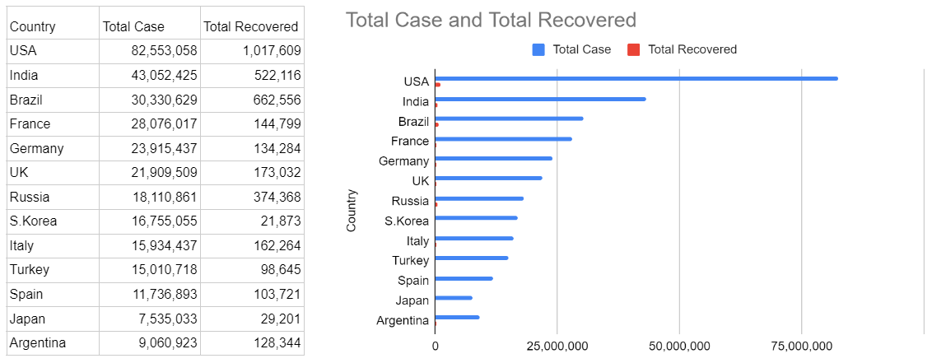

**COVID STATISTICS IN COUNTRY**

Example 2:

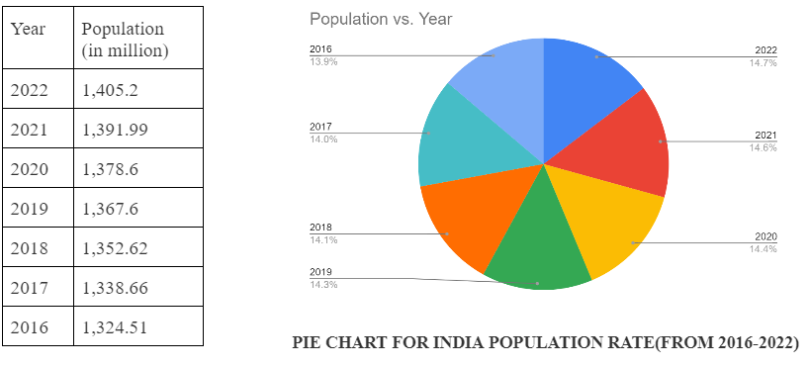

**HOW?:**



1. The user will provide a file in the dashboard.

2. Triggers the controller.

3. Controller will send the file to the validator.

4. Validator checks the file and sends the request to the file reader.

5. FileReader reads the data from the excel file and sends the data to the graph generator for generating the graph.

6. By using that data, the Graph generator creates charts.(it may be pie chart, bar graph, line graph).The chart will be shown in the dashboard.

**WHY?:**

* We have chosen the above design because it is easy to understand and start the work.
* We can always enhance the experience by adding new features.

**TECHNICAL SPECIFICATION**:

| Language | Python |
| --- | --- |
| Libraries | TBD |
| OS | Windows |
| Version Control | Github |
| Documentation Tools | Google doc, Google sheet |
| IDE | Pycharm |

**REFERENCE**

* [**https://rawgraphs.io/**](https://rawgraphs.io/)
* [**https://www.tableau.com/**](https://www.tableau.com/)